# Build a password-protected website using AWS CloudFront, Lambda and S3

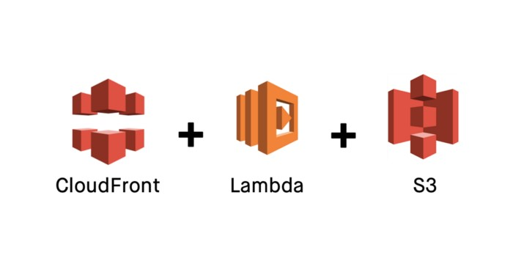

**All services created in N.Virginia**

Step 1 : Create S3 bucket and upload static website. Step 2 : Create IAM Role For Lambda & cloud front.

-> Basic Lambda@Edge permissions

Step 3 : Create Lambda Function and Upload Code and code publish.

Step 4 : Create Cloud Front.

Step 1 : Create S3 bucket and upload static website.

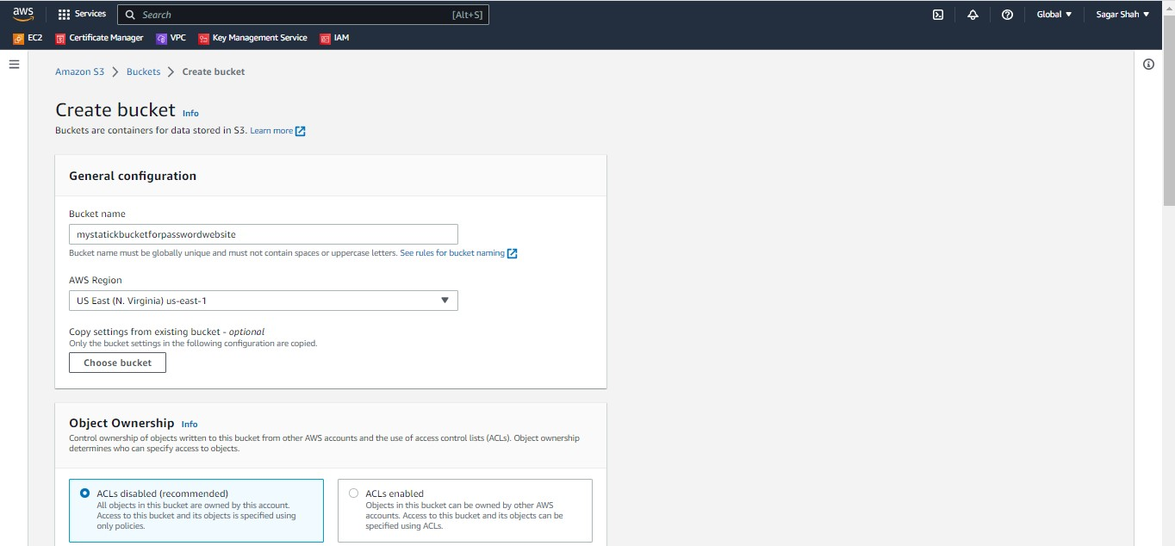

S3 bucket create for Private object.

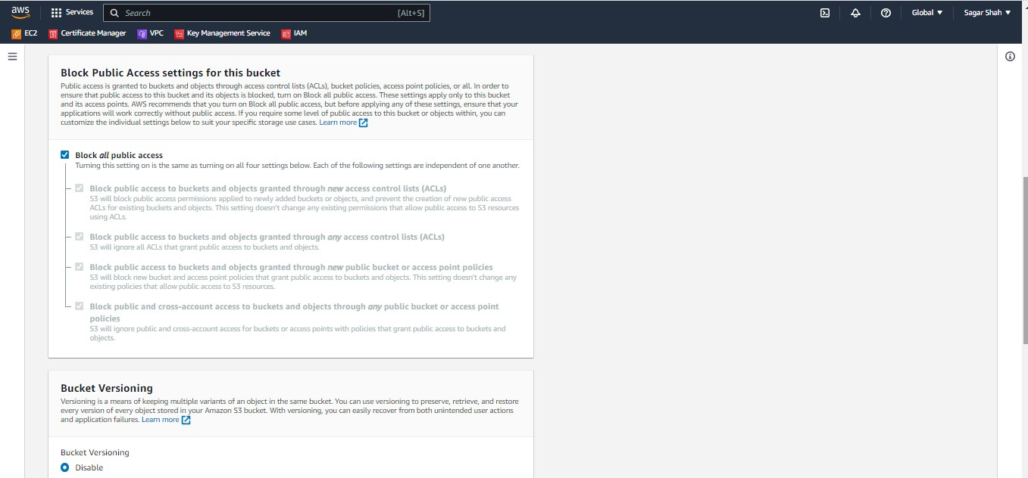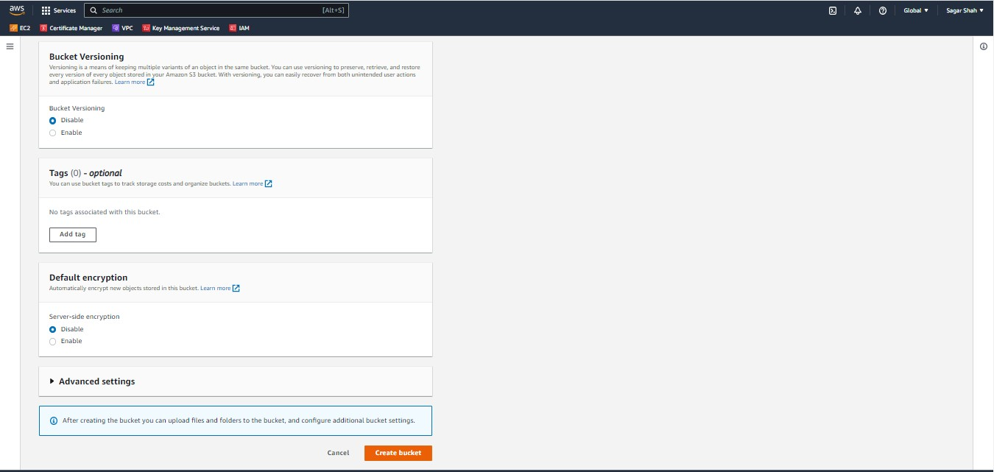

S3 bucket is successfully created.

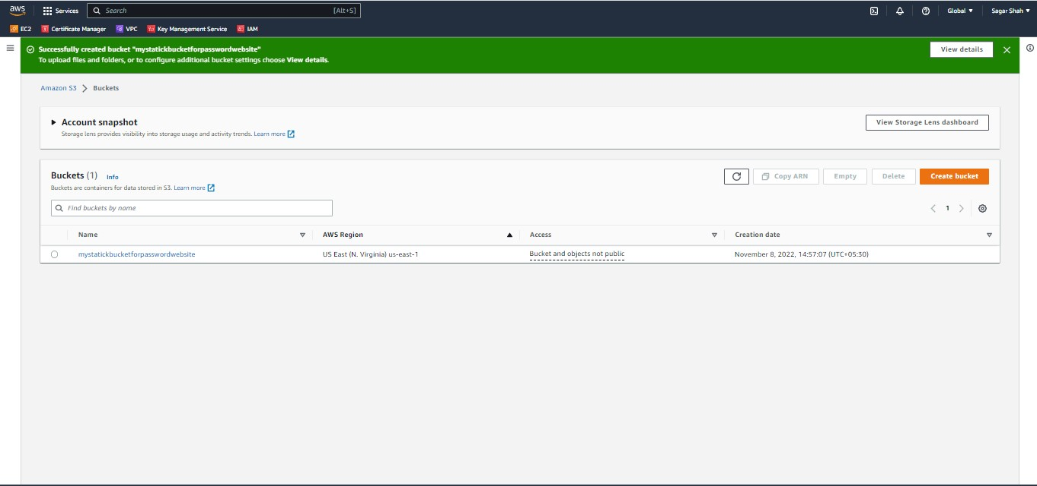

Download static website from this link https://www.free-css.com/free-css-templates

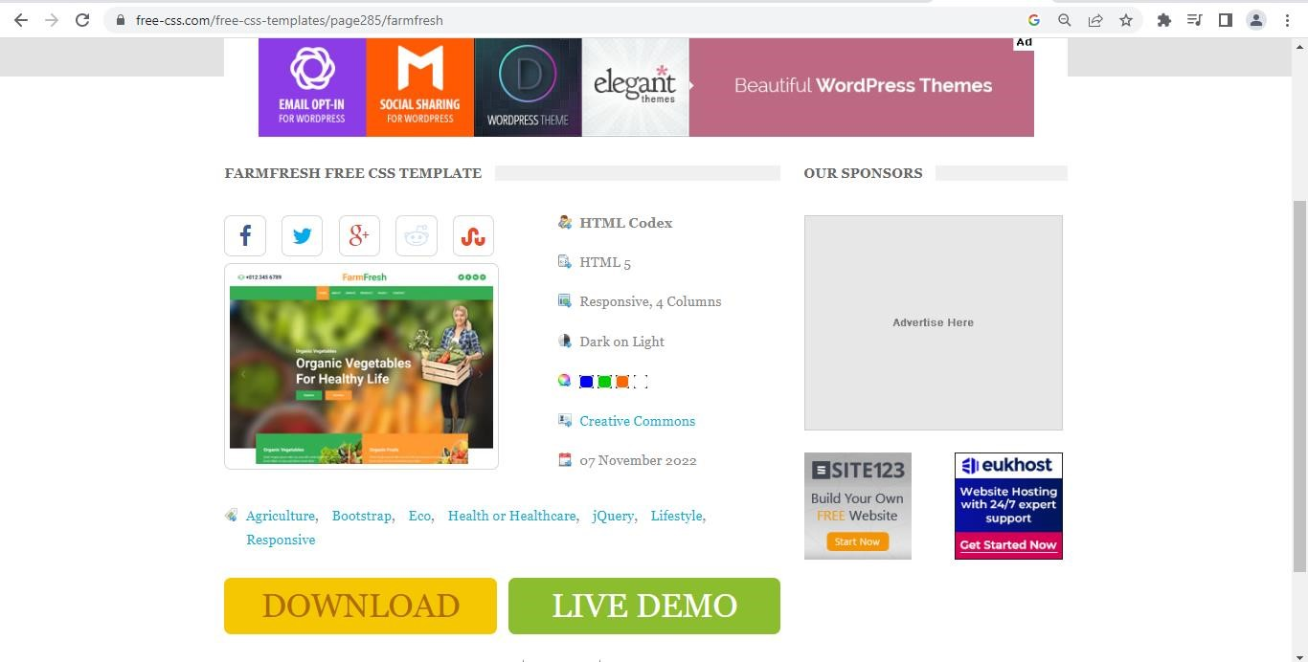

Website upload to S3 bucket.

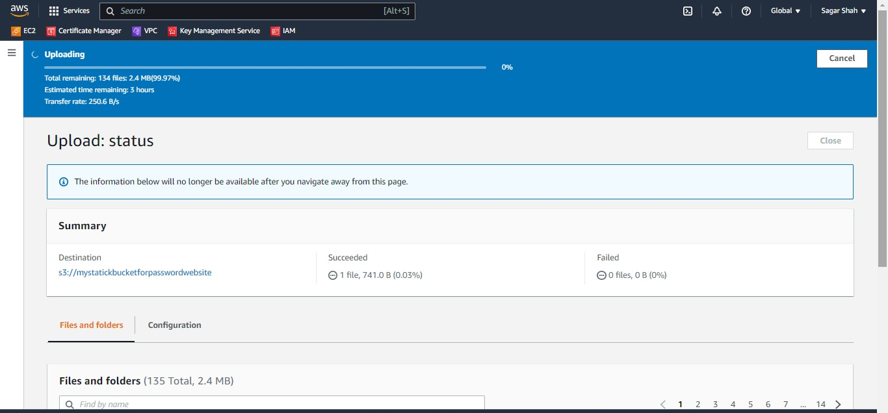

Bucket and Object are Private.

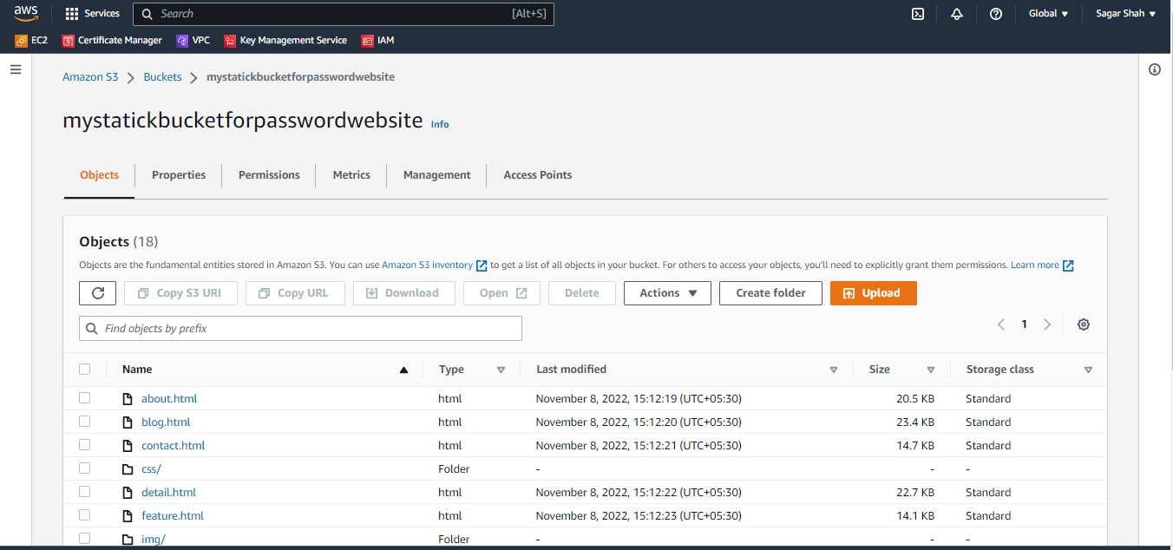

Step 2 : Create Lambda function.

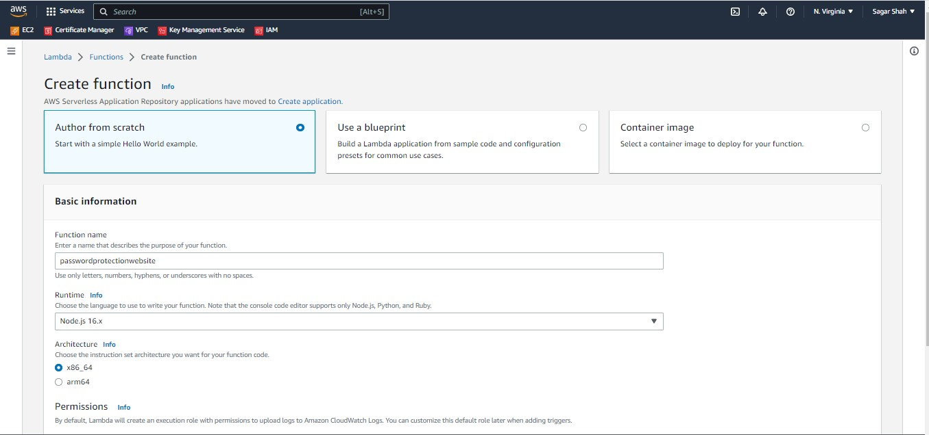

Create IAM Role For Lambda & cloud front.

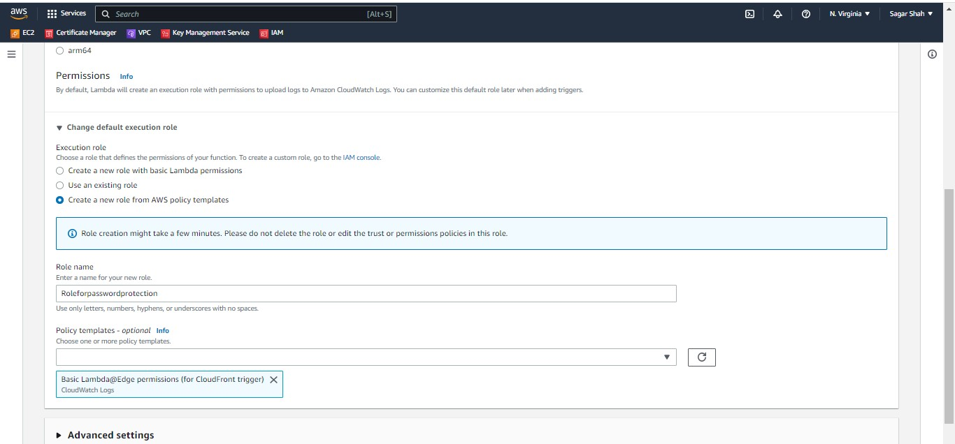

Code upload on Lambda function.

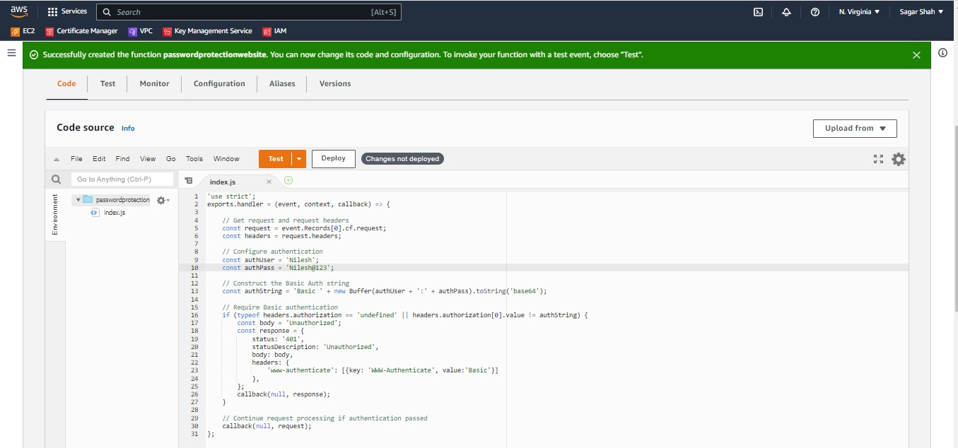

Publish of code.

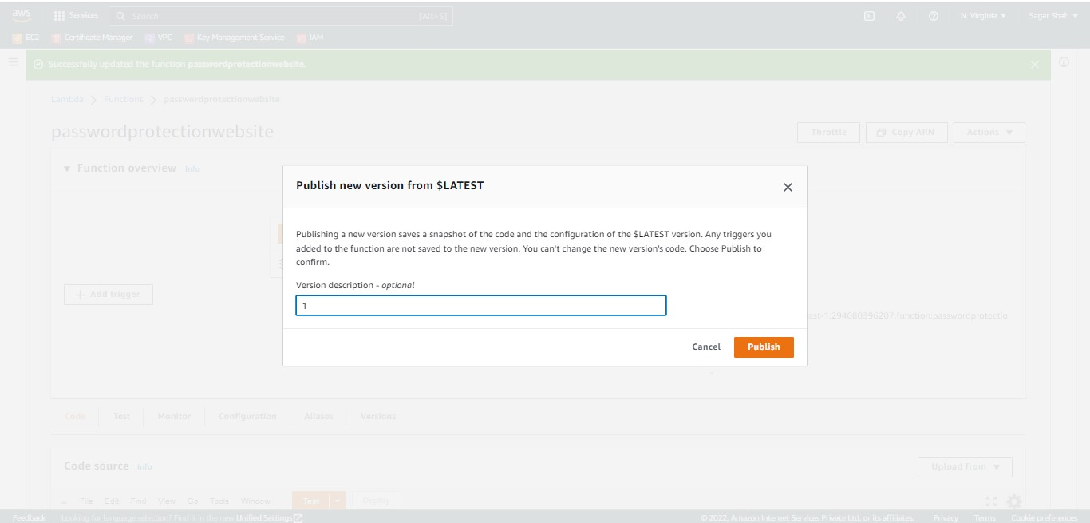

Step 4 : Create Cloud Front.

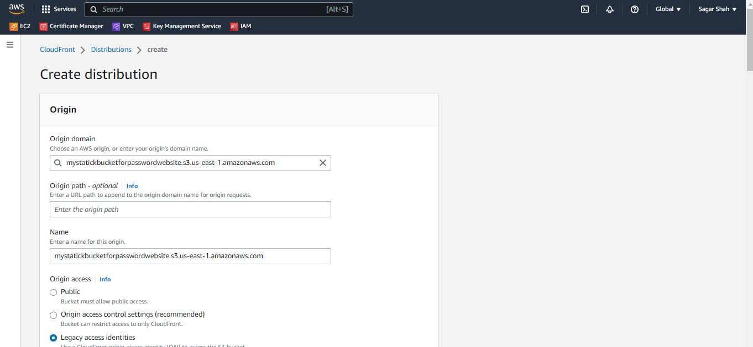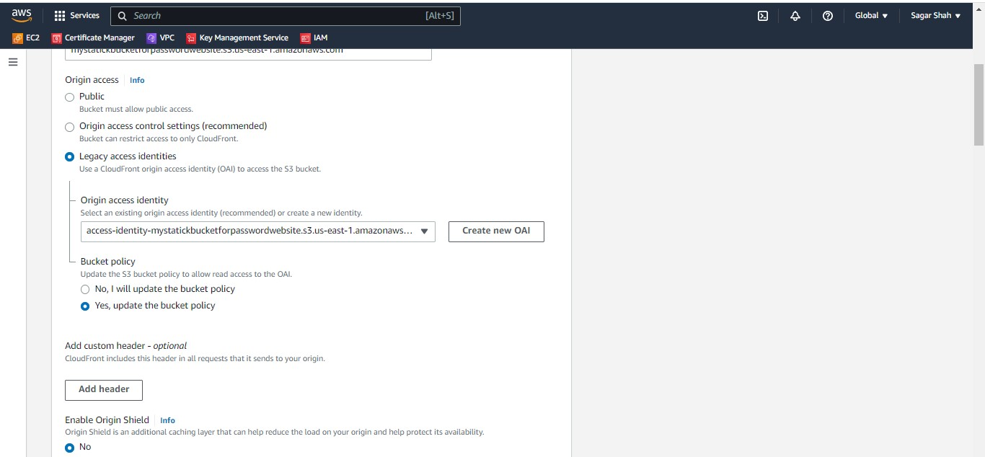

Copy of ARN from Lambda Function.

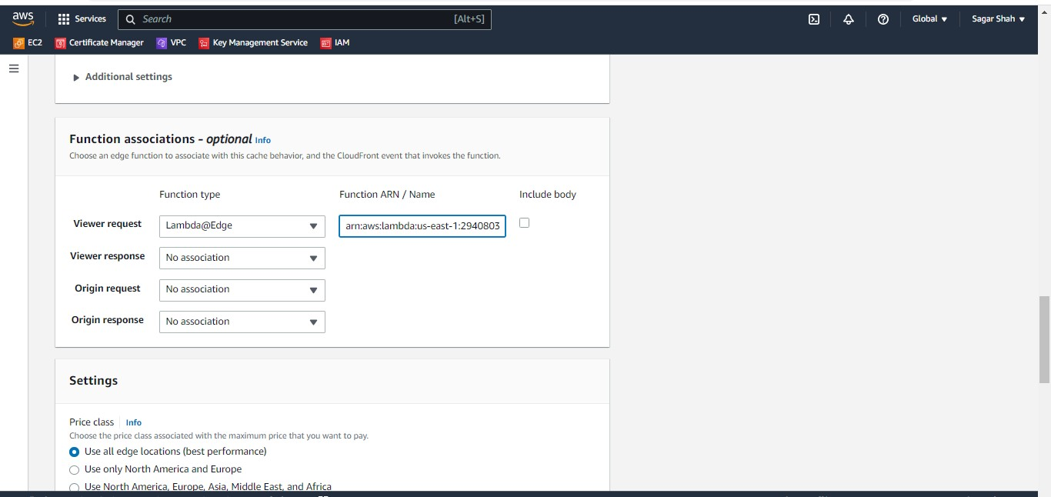

Our website is index.html so that root object is index.html

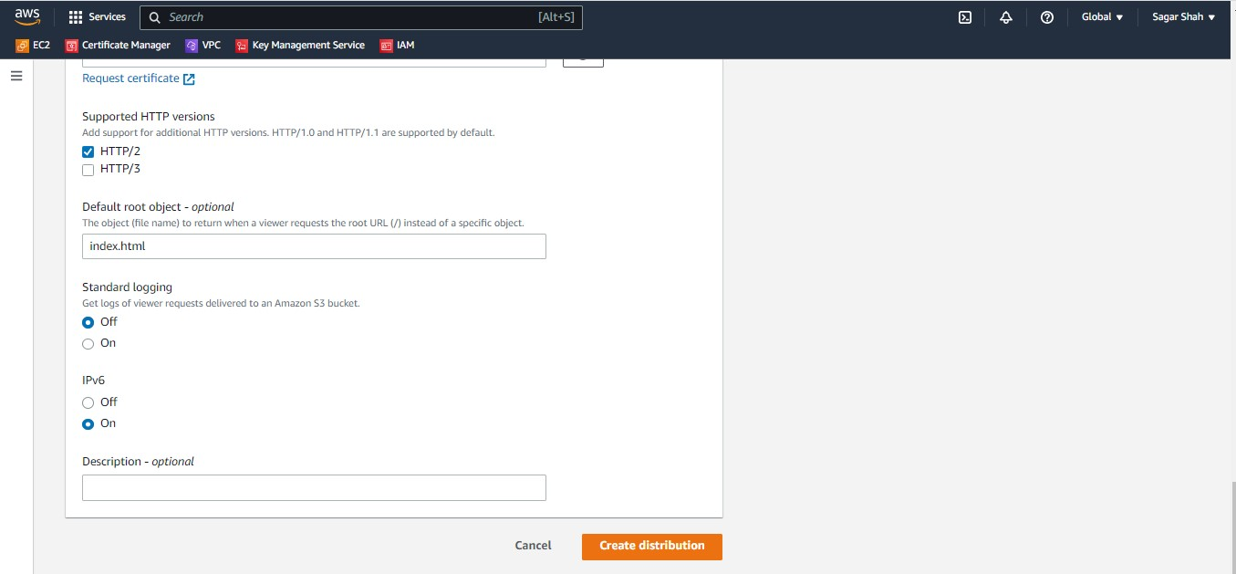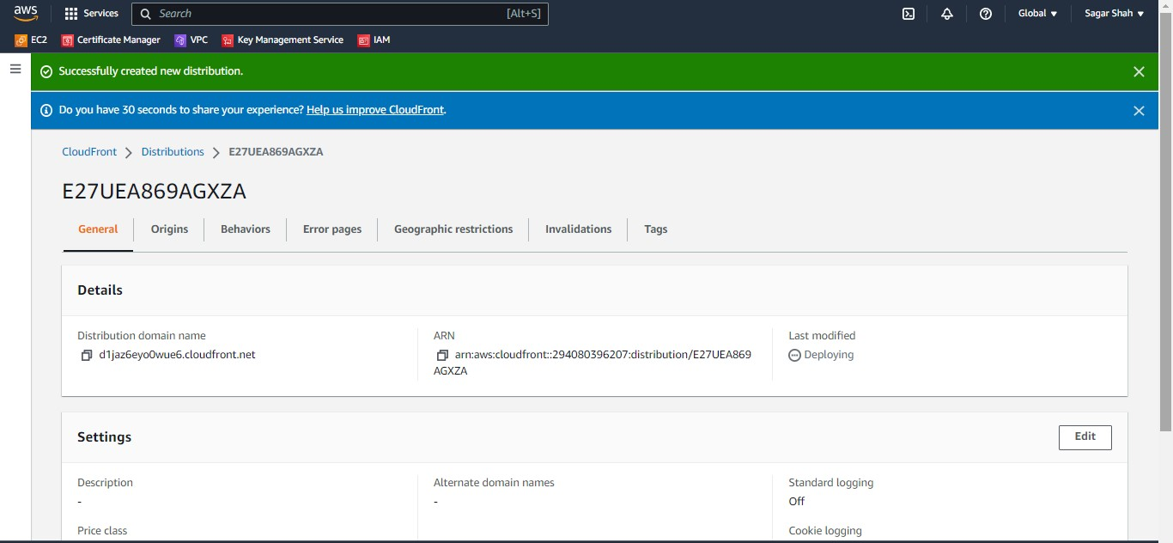

Distribution domain name copy and past on you browser.

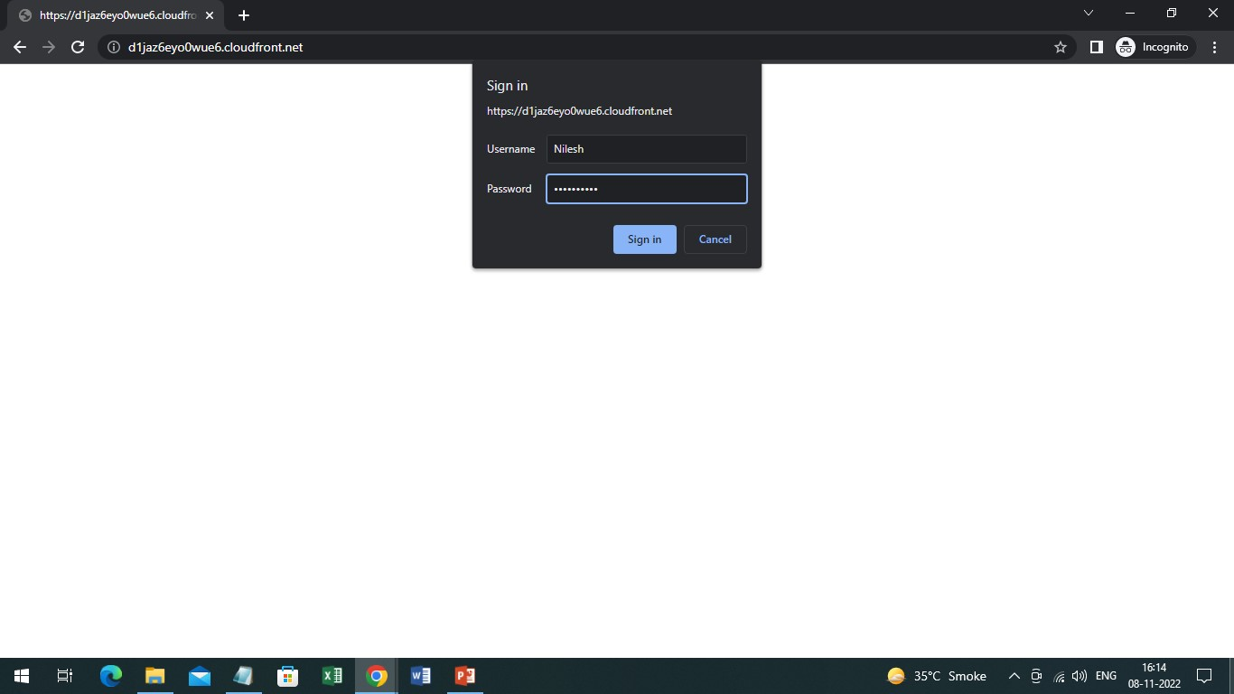

After that Check out of Static website.

